A Radiofrequency Coil for Ultra Low-Field MRI
Design Roadmap
500-CO-1-Coil

Project Manager
Spencer Tourigny, 30117572, spencer.tourigny@ucalgary.ca

Team
Sonny Bruni, 30149849
Ian Washington, 30116633
Jennifer Bee, 30094595
Yuri Lemermeyer, 30143884
Kenshin Pacle, 30116862

Support Technician
Mateo Alzate

Academic Advisor
Dr. Chathura Kumaragamage

Company Sponsor
Brain Image Team (BIT) Lab
Dr. Ethan MacDonald, ethan.macdonald@ucalgary.ca
Table of Contents
1 Glossary 4
2 Short Bios 4
2.1 Spencer Tourigny 4
2.2 Jennifer Bee 4
2.3 Ian Washington 5
2.4 Sonny Bruni 5
2.5 Kenshin Pacle 5
2.6 Yuri Lemermeyer 5
3 Project Motivation and Objectives 5
3.1 Motivation 5
3.2 Objectives 6
4 Project Scope and Deliverables 6
4.1 Project Scope 6
4.2 Project Deliverables 7
5 Preliminary Design of the Proposed Solution 7
5.1 Coil 9
5.2 TR Switch 10
5.3 RF Amplifier 10
5.4 Tuning Circuit 10
6 Alternative Solutions and Methodologies 11
6.1 General Approach to Design Alternatives 11
6.2 Simulation Software Alternatives 11
6.3 RF Coil Design Alternatives 11
6.4 TR Switch Design Alternatives 12
6.5 Power Amplifier Design Alternatives 13
7 IP and Other Legal Agreements 13
8 Technical Specifications 13
9 Materials, Supplies, Tools, and Cost Estimates 14
10 Risks and Risk Mitigation Plans 14
11 Major Technical Tasks and Milestones 16
12 Roles and Responsibilities 18
13 Measures of Success and Validation Tests 20
14 Team Logbook 20
15 References 21

Glossary
Acronyms | Definitions
RF | Radio Frequency
MRI | Magnetic Resonance Imaging
TR | Transmit-Receive
FID | Free Induction Decay
PCB | Printed Circuit Board
ULF | Ultra Low Frequency
Table 1: Definition of Acronyms Used Throughout the Document

Terms | Definitions
Larmor Frequency | Frequency of a charged particle’s magnetic moment in an external magnetic field
Free Induction Decay | Time-domain signal that appears immediately after a radio frequency pulse excites a sample’s nuclear spins.
Specimen | The object being imaged by the MRI
Table 2: Definition of Terms Used Throughout the Document

Short Bios

Spencer Tourigny
Final year Electrical Engineering and Commerce dual degree student. Industry experience in facilities engineering, electrical design, and maintenance engineering. Also completed a summer of undergraduate research in the University of Calgary control systems lab.

Jennifer Bee
Final year Electrical Engineering student with internship experience at the department of National Defence. Experience within RF detection systems and researched diode detection through RF excitation.

Ian Washington
Final year Electrical Engineering student with industry experience in fiber optic technology, data processing algorithms, and pipeline operations. Completed a digital engineering-focused fellowship opportunity at the University of Calgary.

Sonny Bruni
Final year Electrical Engineering student with industry experience in data analytics, manufacturing and engineering optimization.

Kenshin Pacle
Final year Electrical Engineering student with an industry background in software development and electrical systems. Interests in bridging software to hardware, and artificial intelligence.

Yuri Lemermeyer
Final year Electrical Engineering student with industry experience in power systems and data analytics.

Project Motivation and Objectives

Motivation
MRI is a diagnostic tool used to visualize the body’s internal structures. It is critical in diagnosing several ailments, including brain injuries, tumours, aneurysms, spinal cord conditions, and strokes (Mayo Clinic, 2023). However, conventional MRI machines rely on strong magnetic fields, which require expensive parts and complex fabrication. These factors make MRI technology inaccessible in many parts of the world, especially rural areas and third-world countries.
ULF MRI addresses this problem by offering an alternative approach. It uses weak magnetic fields, effectively reducing the size, cost and complexity of MRI systems. However, using a weak magnetic field creates new challenges, such as weak signals and blurry images, requiring thoughtful design to create a feasible solution. The RF coil, the part of a MRI which transmits and receives signals from the object being scanned, is especially impacted by the use of ULF, as the signal-to-noise ratio radically decreases in ULF applications.

Objectives
The main goal of this project is to design, build and test an RF coil optimized for ULF MRI applications. By completing this project, the team aims to contribute to the development of more affordable and accessible MRI technology. Ultimately, this project supports efforts to make healthcare more equitable and affordable through innovative engineering.

Project Scope and Deliverables

Project Scope
The scope of this project entails the design, fabrication, implementation, and validation of an RF coil to be used in the application of an ultra-low field MRI. The coil will serve as the primary driver for nuclear spin excitation in the specimen, as well as the reception of the free induction decay signal after radio signal pulsation at the Larmor frequency.
The final system shall include:
- An RF Coil.
- A tuning circuit that optimizes power transfer to the coil.
- A TR switch to control transmitting and receiving modes of the coil.
- An RF power amplifier to drive the Larmor frequency signal to the coil.
The coil, as well as the supplemental components shall be designed given the constant that the ultra-low field MRI produces a constant magnetic field of 50mT.
Functionality wise, the RF coil shall be capable of bimodal operation, utilizing both transmit and receive modes governed by the TR switch. In transmit mode, the coil shall be able to deliver an RF signal at the Larmor frequency corresponding to the defined magnetic field strength, driven by an RF amplifier, to induce excitation in the specimen. In receiving mode, the coil shall detect the FID signal resulting from free induction decay.
Constructing an image from the FID signal, main magnetic field generation for magnetizing the specimen, or any other functionalities that a completely functional ultra-low field MRI has is out of scope for this project.

Project Deliverables
Must-Have:
  - Functional RF Coil able to transmit and receive.
  - RF amplifier either designed or bought.
  - T/R Switch either designed or bought.
  - Tuning Circuit, tuning the coil for max power designed on a PCB.
  - Bill of materials.
  - Simulation results.
  - CAD Models for enclosures and Drawings.
  - 3D Printed enclosures for relevant components.
  - Documentation regarding design, as well as any supporting documentation or calculations.
  - Validation results, as well as metrics for performance of the system.
Should-Have:
- Modular PCB layout for Tuning circuit
- Solenoid coil design as opposed to traditional coil design.
- External circuit protection consisting of relays and fuses spread out through the components of the design.
Nice-to-Have
- Coil segmentation, Bandpass filters, decoupling capacitors, or any other noise mitigation implementations.
- Heat protection.
- Aesthetically pleasing enclosure.

Preliminary Design of the Proposed Solution
The RF coil system can be represented by the block diagram in Figure 1.
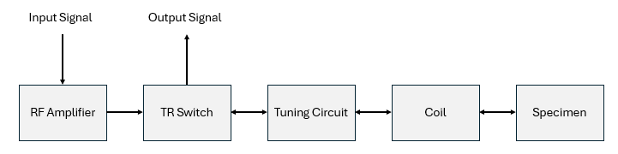
Figure 1: System Block Diagram

The basic function of the RF coil system is to take an input signal (supplied to the system, outside the scope of the project) and use it to generate a visualization of the specimen in the MRI. This visualization signal is outputted from the RF coil system to be processed (image processing is outside the scope of this project).
The RF coil performs this functionality by oscillating between two modes of operation: transmitting and receiving.
In transmission mode the system behaves as shown in Figure 2. The input signal is amplified by the RF amplifier and passes through the TR switch. The coil acts as a transmitting antenna, transmitting the signal into the specimen. This causes the spins of the hydrogen atoms in the specimen to align, creating a net magnetic moment in the specimen (Gould & Edmonds, 2023).
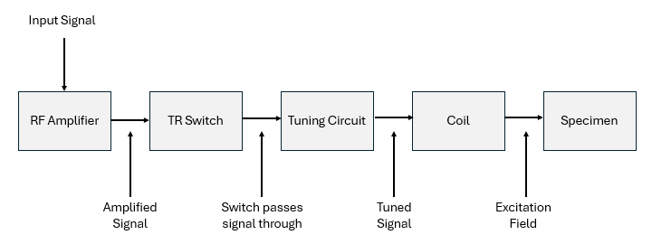
Figure 2: Transmission Mode Diagram

The system than switches to receiving mode. This causes the coil to stop acting as a transmitting antenna, ceasing the excitation of the specimen. However, the net magnetic moment in the specimen takes a while to decay (Gould & Edmonds, 2023). This gives us the chance to use the coil as a receiving antenna, picking up the FID signal generated by the specimen. This signal is passed through the RF coil system as shown in Figure 3, eventually being outputted and used to produce the visualization of the specimen.
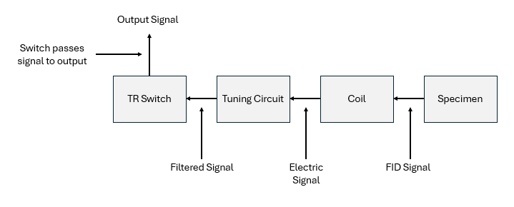Figure 3: Receiving Mode Diagram

These block diagrams show the project design can be broken into 4 main components: the coil, the TR switch, the RF amplifier, and the tuning circuit.

Coil
The coil is made up of an antenna and housing. The size of the coil and coil housing is very important because it must fit the specimen inside it, while being able to fit inside the larger permanent and gradient magnets itself. Sizing requirements are given in the technical requirements. To reliably meet these sizing requirements, and simplify construction of the housing, the housing will be 3D printed.
The antenna itself can have several design alternatives, though most involve wrapping magnet wire around the housing in some configuration. These configurations will be discussed in the alternative solutions section below. The use of magnet wire is important for the antenna to effectively transmit a signal to the specimen.

TR Switch
There are several TR switch designs which have been used in MRI systems over the years, including both active and passive switching options. To avoid repetition, I will save the discussion of these alternative switches and our planned path forward for the alternative solutions section of this report.

RF Amplifier
Our sponsor purchased an RF amplifier prior to the beginning of our project with them. This purchased RF amplifier is a Tomco brand 3MHz RF amplifier. Our design should be compatible with this amplifier.

Tuning Circuit
Our tuning circuit will be based off the design done by Tom O’ Reilly and Lukas Winter, who developed a tuning circuit for a similar ULF MRI application (O’ Reilly & Winter, 2025). A schematic of O’Reilly and Winter’s tuning circuit design is given in Figure 4.
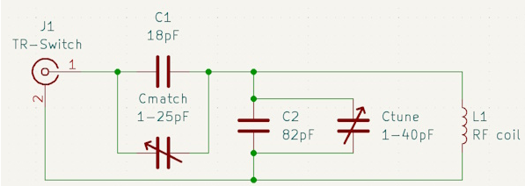
Figure 4: O’Reilly and Winter's Tuning Circuit Schematic

However, our design will have to make a few changes to this design. First, the variable capacitors they used are not readily available in North America. Instead, we will use alternative variable capacitors in our designs. These capacitors have different capacitance ranges than the ones used by O’ Reilly and Winter. To get an equivalent circuit with different capacitance ranges, we will need different capacitance and inductance values for static components. To test that our redesigned circuit still functions correctly, we will prototype it on a breadboard, to test its functionality. After we have confirmed the functionality of our tuning circuit, we will print a tuning circuit PCB, to eliminate any stray breadboard capacitances from the final design.

Alternative Solutions and Methodologies

6.1 General Approach to Design Alternatives
Since low-field MRI devices are a new technology with limited pre-set industry standards, and limited literature and research papers available, there have been cases where the team and/or sponsor have chosen to use off-the-shelf, pre-built components for initial testing and validation. This way, troubleshooting is much more straightforward and there is a working example with which to base further designs off.
The downsides of using this approach are that in some cases using pre-built components is more expensive than designing a solution ourselves, and that pre-built components are more difficult/impossible to modify if needed.

6.2 Simulation Software Alternatives
Simulation software was chosen based on familiarity, technical capabilities, and cost. The three main options considered were Python, MATLAB and Ansys Electronics Desktop. MATLAB was familiar to the team but not specifically for electromagnetic and radio-frequency modelling and is limited to relatively rudimentary geometric modelling. For our use case, Python has mostly the same benefits and drawbacks as MATLAB. Experience with Ansys was limited to a few labs in previous classes, however it has superior ability to model geometry, and simulate radio frequency responses. MATLAB and Ansys provide university students access to a free version. In Ansys Electronics Desktop Student the user is limited to 10,000 meshes which has limited, but not detrimentally so our simulations. We chose Ansys as a more specialized and powerful tool for MRI modelling.

6.3 RF Coil Design Alternatives
For the design of the main RF coil, we considered three configurations: birdcage, solenoid (helix), and surface coils. Factors considered included the specialization of the coil, such as depth of imaging and quality of signal to noise ratio. We also took into account coil design, simulation and manufacturing complexity. Lastly, we considered availability of open-source information about design and performance as a favourable source of guidance. Surface coils would have been a strong choice in a different context of imaging. If our focus was limited to shallow images (such as wrists, elbows, knees, etc.) we would have considered these coils further. However, these designs are very complex and the amount of open-source information available regarding these coils is not plentiful. Between the remaining two choices of coils, birdcage have better field homogeneity. While this is an important parameter, it was outweighed in favour of the solenoid design’s superior signal to noise ratio, significantly simpler design and plentiful access to open-source resources. We heavily referenced open-source resources provided by Lukas Winter, and our initial design closely follows his Solenoid d205mm N20 3seg design (O’Reilly & Winter, 2023).

6.4 TR Switch Design Alternatives
The TR switch is one of the most open-ended parts of the overall design, with many possible solutions according to cost, space, switching time, isolation, and power handling constraints. Preliminary research into TR switches used by other teams attempting to build similar MRI machines yielded two potential open-source options: a passive TR switch with limited design specs and material list, and an active TR switch PCB with a complete bill of materials and PCB design files.
Further research was done into using an off-the-shelf radio-frequency switch instead of the open-source options. A paper published by a team building and testing a similar low-frequency MRI device compared 4 different TR switch designs using switches available for purchase online (Sappo et al., 2020).
Table 3 was included in the paper and compares four metrics that are important for determining the efficacy of the TR device. The passive switch here is similar to the other passive switch used by other teams. Based on these results, along with the price of each TR switch, we decided to use the ADG1412 digital switch for initial testing. This switch has the best switching speed and isolation, good power handling and insertion loss, and is relatively cheap.

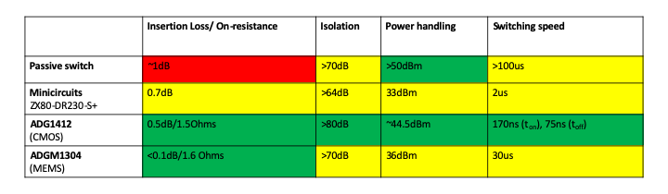
Table 3: Comparison of TR Switch Alternatives

6.5 Power Amplifier Design Alternatives
Other groups designing low-field, low-cost MRI devices have often built their own power amplifiers for their design. However, for our project, our sponsor chose to buy a power amplifier for the first stage of development. If time and resources permit, developing our own power amplifier could be possible.

IP and Other Legal Agreements
This project is governed by the sponsor-team contract. Both the sponsor and the team have copies of this contract, and it has also been submitted on D2L. This contract gives possession of the project results, including any IP to the sponsor.

Technical Specifications
Specification | Requirement
Coil type | RF solenoid
Coil turns | 20
Coil length | 20cm
Coil diameter | 20.5cm
Wire length | ~12.9m
Weight (solenoid and tuning circuitry) | <8lbs
Coil body material | PLA
Reflection coefficient magnitude at tuned frequency | |S11| < -12dB
Budget | $1900
Table 4: Project Technical Specifications

Materials, Supplies, Tools, and Cost Estimates
Materials | Cost Estimate | Purpose
3D-printed chassis | $0 | Main body for RF coil
Magnetic wire | $300 | Wire for winding coil
Variable capacitors (x2) | $700 | Tuning Circuit
Ceramic capacitors | $0 | Tuning Circuit
Tuning Circuit PCB | $100 | Tuning Circuit
Breadboard | $0 | Tuning Circuit (testing)
TR Switch | $400 | TR Switch
Amplifier | $300 | Amplifier
Simulation Tools | $100 | Simulation and Design Testing
Table 5: Project Materials and Supplies with Cost Estimates

Equipment | Purpose | Access
Network Analyzer | Testing | Sponsor's lab
Oscilloscope | Testing | Sponsor's lab
3-D Printers | Printing 3D chassis | Sponsor's lab
Soldering station | PCB assembly | Electrical makerspace
Ansys software | Simulations | Free software
Signal generator | Generate RF signal | Sponsor’s lab
Table 6: Project Tools and Lab Equipment
The overall project budget is $1900 +/- 10%.

Risks and Risk Mitigation Plans
Deliverables | Risks | Mitigation Plans
RF Coil | 1) Copper wire does not arrive within appropriate time.  2) Solid copper wire is not effective for receiving. | 1) Monitor delivery progress and make another local order if needed.  2) Make simultaneous order for stranded copper wire.
RF Amplifier | 1) Internal circuit protection does not work, and the RF amplifier gets burned out.  2)RF amplifier does not meet the requirements. | 1)Create external circuit protection for the system, ensuring either relays or fuses burn before amplifier is harmed.  2)Switch out RF amplifier or add external circuit supplementing RF amplifier.
T/R Switch | 1) TR device gets burned out or otherwise damaged during testing/operation  2) TR switch does not meet switching time requirements needed to effectively receive signal back from the sample | 1) For devices with limited built-in power protection, extra units may be acquired in case one gets damaged.  2) Do appropriate research and simulations to ensure that the switching time will work
Tuning Circuit | 1) Components purchased for the tuning circuit meets the requirement of the reference coil, but not the requirements of the bird cage design.  2)Tuning circuit gets burned. | 1.1) Design the PCB to be modular, or similar to a capacitor bank allowing the addition of components.  1.2) Breadboard the design first, then order the PCB.  2)Add external circuit protection.
Simulation | 1) Sponsor takes too long to find professor that can provide full Ansys access | 1.1) Request purchase of Ansys license during next meeting with sponsor  1.2) Make simulation using MATLAB or Python if Ansys license purchase is not an option
Testing and Validation | 1) Network Analyzer delivery is further postponed or cancelled | 1) Ask sponsor during next meeting to look into Network Analyzer options on campus
Table 7: Project Risks and Risk Mitigation Plans

Major Technical Tasks and Milestones
Phase | Milestone | Tasks
Phase 1: Research & Component Acquisition. | Gaining technical aptitude and completing procurement of materials.  Timeline:  Start of Project – Fall Term Progress Evaluation | - Study what an ULF MRI is.  - Study RF principles.  - Definition of team roles.  - Identify components needed for the system.  - Identify input signal characteristics such as amplitude and frequency.  - Preliminary coil simulations.  - Base schematics of the tuning circuit.  - Acquisition of materials needed for phase 2.  - Finalize design characteristics such as coil size, etc.
Phase 2: Prototype System, | Prototype coil system to be assembled and tested to be used for baseline metrics.  Timeline:  Fall Term Progress Evaluation – Start of Winter Semester | - Prototype design based on documentation.  - Implement all components of the system discussed in Phase 1.  - Perform and document validation tests for performance and benchmarking.  - Requisition additional parts as needed.
Phase 3: Solenoid Coil Design and Fabrication. | Fabrication of the solenoid coil to improve system performance  Timeline:  Start of Winter Semester – Winter Term Progress Evaluation | - Simulation of solenoid coil.  - Design solenoid coil.  - Construct solenoid coil.  - Requisition additional parts as needed.
Phase 4: Solenoid Coil Tuning. | Tuning circuit matched to the coil.  Timeline:  Winter Term Progress Evaluation – Mid-February 2026 | - Create a tuning circuit for the solenoid coil.  - Requisition additional parts as needed.
Phase 5: Final Validation tests. | Final testing of the solenoid coil  .  Timeline:  Mid-February 2026 – Final Presentation | - Perform and document final validation tests to compare to the original design.  - Requisition additional parts as needed.
Table 8: Project Phases and Milestones
The Major technical tasks and milestones have been split into phases that reflect a hybrid agile development process.
Phase 1 is the preliminary stage of the design. Essentially FEED. It lays the foundation for the group to understand what exactly an ultra-low field MRI is, and how the system being developed fits into the puzzle. This is also time to requisition parts that will be needed for phase 2 and further phases.
Phase 2 puts everything established in phase 1 into motion. A physical product is produced that will serve as the baseline that will be improved upon in further phases.
Phase 3 is the design and fabrication of a solenoid coil intended to surpass the baseline system in efficiency and quality of FID signal received. Efforts are to be focused on optimizing coil geometry and material selection to improve RF performance.
Phase 4 is integrating a custom-tuned circuit to ensure impedance matching and resonance at the target frequency. PCB adjustments or re-iteration from baseline are made as necessary to accommodate new coil parameters.
Phase 5 is comprehensive testing conducted to evaluate the performance of the solenoid coil against the baseline. This is also closeout.
Note that the phases set up are meant to mimic the project life cycle gating control standards used within industry.

Roles and Responsibilities
Member | Role
Spencer | Project Manager:  - Ultimately responsible for all course deliverables  - Responsible for coordinating meetings with the sponsor, TA, and academic advisor, as well as internal meetings  - Responsible for assigning and enforcing internal deadlines  - Responsible for overall system architecture and ensuring the designs of each sub team are compatible  - Also accountable for assisting coil and TR switch leads on technical duties, as required
Jennifer | Coil Lead:  - Responsible for the design and 3D printing of the coil  - Responsible for the construction of the coil  - Responsible for the testing and validation of coil parameters (impedance value, S11 parameter, etc.)  - Responsible for coil documentation  - Also accountable for assisting simulation lead on technical duties, as required
Ian | TR Switch Lead:  - Responsible for the research of alternative TR switches  - Responsible for the testing of alternative TR switches and evaluation of their technical capabilities  - Responsible for the selection of the final TR switch from the alternatives  - Responsible for TR switch documentation
Sonny | Simulation Lead:  - Responsible for the simulation of the coil design, and determining theoretical parameters  - Must consult with coil lead to ensure the simulated design matches the real coil  - Responsible for simulated alternative designs  - Responsible for documenting simulation results
Ken | Tuning Circuit Lead:  - Responsible for the design of the tuning circuit  - Responsible for the prototyping of the tuning circuit  - Responsible for the validation of the tuning circuit design  - Responsible for investigating alternative amplifier designs and implementations  - Also accountable for assisting tuning circuit PCB lead on technical duties, as required
Yuri | Tuning Circuit PCB Lead:  - Responsible for the design of the tuning circuit PCB  - Responsible for the testing and validation of the PCB  - Also accountable for assisting tuning circuit lead on technical duties, as required
Table 9: Project Roles and Responsibilities

Measures of Success and Validation Tests
Signal Quality Testing
- Using the network analyser, we will find the of the tuning circuit. To be successful, the resonance frequency should be close to the middle of the chart, implying good or near perfect tuning (e.g. minimal VSWR).
System Stability Testing
- There should be no thermal drift in the system. The coil and electronics should be able to remain stable and working over long periods of operating time. To test this, we will measure the frequency drift due to temperature changes as the coil operates. To be successful this drift should be insignificant.
Coil Parameters
- Using the network analyser, we will measure the S11 reflection coefficient of the coil. To be successful the magnitude of the measured value at the tuned frequency should be less than -12dB.
Coil Geometry
- Using a measuring tape and scale, we will measure the geometry and weight of the coil and coil housing. If these values meet the technical specifications, this test will be considered successful.

Team Logbook
A logbook will be created using Planner in Microsoft Teams and will include sections such as Backlog, Up Next, In Progress and Completed. Anyone in the team may add a new task within these sections. These tasks will be updated to indicate progress, and any important updates regarding the task which were shared during team meetings. Team members will be responsible for updating the logbook ensuing all work on the project, and discussions during team meetings, are logged. Team members must also update the sections in which their tasks reside. For instance, a task that is no longer in progress must be updated as complete. This will ensure effective organization and logbook maintenance. Lastly, the project manager will be responsible for reviewing the logbook during each internal meeting and ensuring consistent and appropriate use.

References
Gould, T. A., & Edmonds, M. (2023, June 9). How MRI works. How Stuff Works. https://science.howstuffworks.com/mri.htm
Mayo Clinic. (2023, September 9). What is an MRI scan used to diagnose? https://www.emedicinehealth.com/what_is_an_mri_scan_used_to_diagnose/article_em.htm
O’Reilly, T., & Winter, L., (2023, January 6). Solenoid d205mm N20 3seg. Gitlab. https://gitlab.com/osii/rf-system/rf-coils/solenoid-d205mm-n20-3seg
O’Reilly, T., & Winter, L., (2025, May 14). Solenoid d150 N20. Gitlab. https://gitlab.com/osii/rf-system/rf-coils/solenoid-d150-n20
Sappo, C.R., Martin, M. N., Shen, S., Koonjoo, N., Kos, A. B., Grissom, W. A., Rosen, M. S., & Stupic, K. F. (2020). Active transmit/receive switches for low field magnetic resonance (<100mT). International Society for Magnetic Resonance in Medicine. https://cds.ismrm.org/protected/20MProceedings/PDFfiles/4067.html#:~:text=A%20TR%20(transmit%2Freceive),effective%20switches%20and%20widely%20used.

